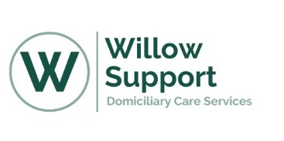

Willow Support – Rockwood Frailty Score
Clients Name: |  | Clients DOB:
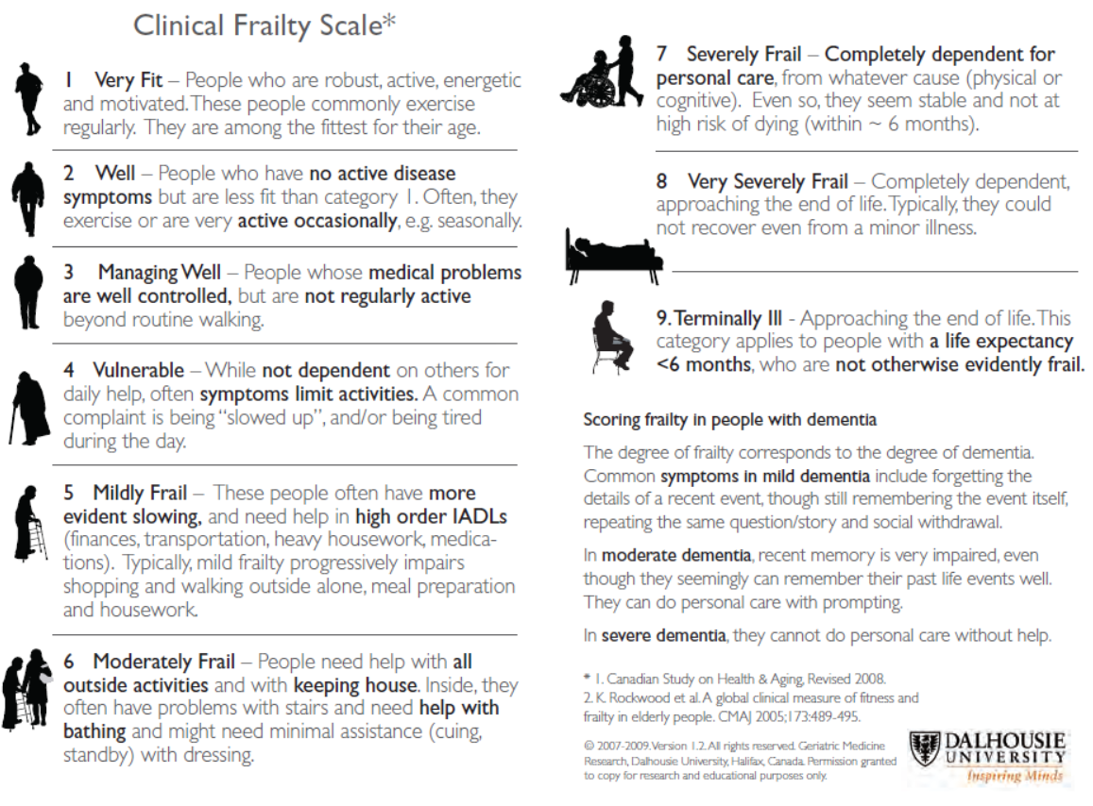

Date Risk assessment completed: |  | Date Risk assessment to be reviewed: |  | Risk assessment completed by:

